**Distance Learning Activity, TUESDAY, MARCH 31:**

**ACADEMIC 10**

**FEEDBACK NOTE:** If you’ve uploaded your “Incident in a Rose Garden” work, you can find your feedback in Canvas. I focused on the poem/play characteristics you noted in the piece. The key is also pasted later in this document.

PHASE 2 of Distance Learning: **WEDNESDAY’S CLASS**

Wednesday and Thursday are designated as days to become familiar with Phase 2 and the new schedule. Wednesday is our day, so note that I will be posting a general instruction powerpoint on SchoolWires for you to review before our class meeting time on TEAMS on Wednesday. You will receive an email invitation to TEAMS, too.

* **Block 1 Wednesday**: 10:00-10:30 am on TEAMS
* **Block 2 Wednesday:** 12:30-1:00 pm on TEAMS

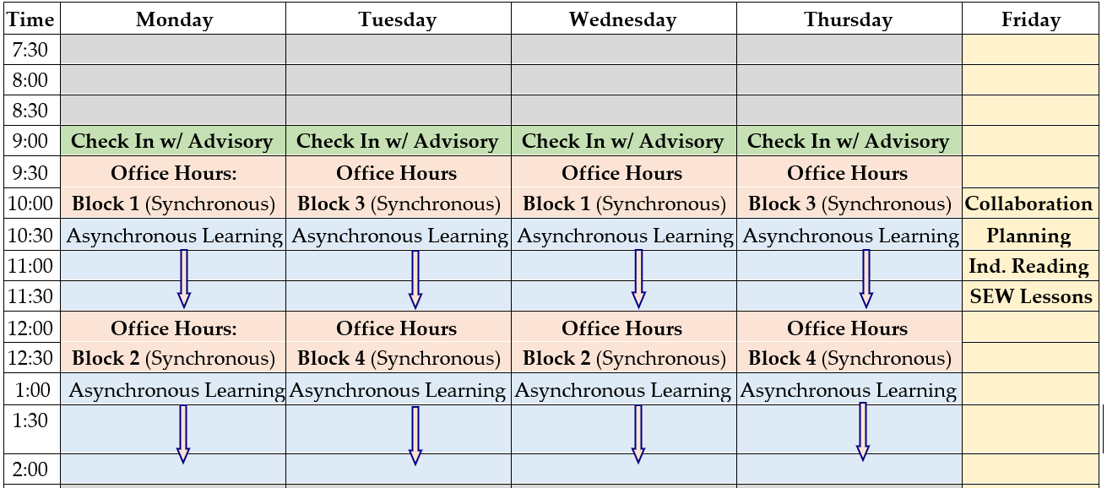

**Overview:**

* Students will practice close reading and annotating.

**Estimated Time:** Approximately 45 minutes

**Explanation/Goals:**

* To review/ “hear”/”watch” the poem “The Raven” through a *The Simpsons* “Treehouse of Horror” reimagining
* To practice close reading/annotating

**Materials:**

* *The Simpsons* version of “The Raven” (Canvas)
* “The Raven” (Canvas)
* Independent reading book

**Things to know:**

* We will move to finish independent reading and complete assessment work once we enter Phase 2 of Distance Learning
* We will work with “The Raven” next week when we review sound devices in poetry
* We are almost done with our poetry review now that we can begin new learning; nonfiction and argument are up next!

**Tasks:** (List the specific tasks the students will complete.)

1. See my key for “Incident in a Rose Garden” below.
2. Check your individual Canvas feedback on “Incident in a Rose Garden”
3. From Canvas open/watch *The Simpsons* version of “The Raven.”
4. From Canvas, open “The Raven,” complete the annotation boxes, and upload to Canvas.
5. When done, work in independent reading and aim for at least 1 post it. We will be moving to some assessment work once we are in Phase 2 of Distance Learning.

**Submission Guidelines:**

* Upload “The Raven” annotations in Canvas, where teacher will provide feedback on “The Raven” at a later time

**SCROLL DOWN for KEY to “Incident in a Rose Garden”**

“Incident in a Rose Garden” by Donald Justice NAME:_KEY______________



**ANALYSIS**:

* What is the gardener’s tone toward death’s arrival? In **GREEN** underline a piece of evidence to support it.

Tone word=apprehensive, fearful

* What is the master’s tone toward death’s arrival? In **BLUE** underline a piece of evidence to support it.

Tone word=annoyed, disdainful, adamant

* In your own words, paraphrase Death’s remarks; consider his interaction with others, how he views his job, and why he is now in the garden:

Many—like the Gardener—are afraid of death, but Death has a job to do. In fact, there is sometimes “friendship,” acceptance, at the end, as there was between Death and the Master’s father. Note, too, Death came not for the Gardener but for the Master!

**GENRE ADAPTATION:** Is this a play or a poem? Some critics disagree. Or is it just that there are elements of both?

**POEM**

* Underline in **RED** two things in the piece that seem to categorize it as a poem, and **label** the poetry characteristic in the margin (personification, imagery—what type?—hyperbole, simile, metaphor, irony, alliteration, etc.).

**PLAY**

* Underline in **PURPLE** two things in the piece that seem to categorize it as a drama, and **label** the drama characteristic in the margin (stage directions, dialogue, prop, sound effect, set design).

*Gardener*  
Sir, I encountered Death   
Just now among our roses  
Thin as a scythe he stood there.  
  
I knew him by his pictures  
He had on his black coat  
Black gloves, and broad black hat.  
  
I think he would have spoken,  
Seeing his mouth stood open.  
Big it was, with white teeth.  
  
As soon as he beckoned, I ran.  
I ran until I found you.  
Sir, I'm quitting my job.  
  
I want to see my sons  
Once more before I die.  
I want to see California.  
  
*Master*  
Sir, you must be that stranger  
Who threatened my gardener.  
This is my property, sir.  
  
I welcome only friends here.  
  
*Death*  
Sir, I knew your father.  
And we were friends at the end.  
  
As for your gardener,  
I did not threaten him.  
Old men mistake my gestures.  
  
I only meant to ask him  
To show me to his master.  
I take it you are he?

